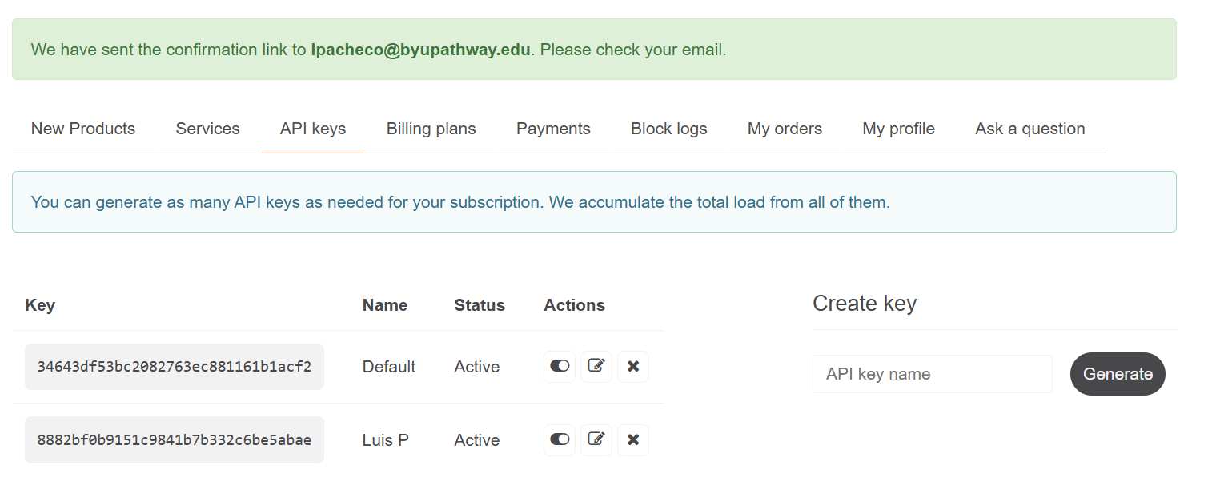

Key | Name | Status | Actions
34643df53bc2082763ec881161b1acf2 | Default | Active
8882bf0b9151c9841b7b332c6be5abae | Luis P | Active

